PROJECT REPORT

Title of Project: Tamil Meme Generator
Name of the Innovator: Dharunya Mahalakshmi B
Start Date: 25-11-2025
End Date: 01-12-2025

Day 1: Empathise & Define

Step 1: Understanding the Need
- Which problem am I trying to solve?
Indian students (200M+ college youth) struggle to create culturally relevant, funny meme captions quickly for Instagram Reels, WhatsApp status, and college groups. Existing AI tools like ChatGPT generate only English captions, missing Tanglish humor, Tamil movie references, exam stress struggles, coding bugs, and festival vibes (Diwali sweets vs diet fails). The global meme generator market is $1.13B (2024) growing at 15.8% CAGR, with Asia-Pacific at 18.6% – yet no culturally localized tool exists for Indian students.

- Who is affected by this problem?
- College students (engineering, arts, commerce)
- Social media creators and Instagram reel makers
- Tamil-speaking youth and regional meme page admins
- Hackathon participants needing quick promotional memes
- How did I find out about this?
☑ Online Research: Discovered $1.13B meme market gap for vernacular tools
☑ AI Tools: Tested ChatGPT/Gemini – poor Tamil humor output
☑ Observation: Friends spend 30+ mins manually editing English captions

Step 2: What is the problem?
No AI tool generates instant Tanglish/Tamil meme captions capturing Indian student life: "Java bugs", "exam morning", "hostel WiFi", "placement rejection", "Diwali diet fail". Students rely on Photoshop/manual typing, wasting hours needed for studies/coding.
Why is this problem important to solve?
India has 500M+ social media users, 200M+ students creating daily memes. A localized AI tool saves 30-60 mins/day, boosts engagement (memes get 3x more shares), and empowers non-designers. With meme market hitting $4.27B by 2033, this fills a massive cultural gap for the world's largest youth population.
Take-home task
Discussed with 7 friends + 2 mentors:
- All want savage Tamil captions for Instagram Reels (coding fails, exam panic)
- Need festival specials (Diwali, Pongal sweets memes)
- Pain point: English AI outputs sound robotic, no "da", "machan" vibe
- Top request: One-click copy for WhatsApp status + Stories
Used Perplexity AI to validate meme market stats and ChatGPT to analyze friend feedback patterns.

Day 2: Ideate

Step 3: List 5 different solutions (with pros/cons):
- AI Meme Caption Bot – Chat interface generates Tanglish captions from topics/images
Pros: Simple, instant. Cons: No visual output
- Tamil Meme Template Maker – Auto-creates complete meme images + text overlays
Pros: Ready-to-share visuals. Cons: Needs image API credits
- Voice Meme Generator – Speak topic in Tamil, get instant captions via speech-to-text
Pros: Hands-free for students. Cons: Speech recognition accuracy issues
- Social Media Meme Scheduler – Plans + auto-posts daily memes to Instagram/WhatsApp
Pros: Full automation. Cons: Complex API integrations
- Meme Battle Arena – Two topics (Exams vs Coffee) compete via AI-generated captions, users vote
Pros: Viral, gamified. Cons: Needs user database

Step 4: My favourite solution:
Tamil Meme Generator – Single-page web app built with Lovable AI (no-code) + OpenAI ChatGPT integration for instant 3-5 Tanglish captions with one-click copy/share.youtube+1​

Step 5: Why am I choosing this solution?
Lovable AI enables rapid prototyping (UI + ChatGPT integration in <1 hour) with mobile-first design, perfect for Instagram sharing. ChatGPT excels at cultural humor understanding ("da", "machan", Tamil movie refs). No-code deployment means zero server management. Other solutions need complex APIs/image processing, but this focuses on caption quality – the real value for students.

Take-home task

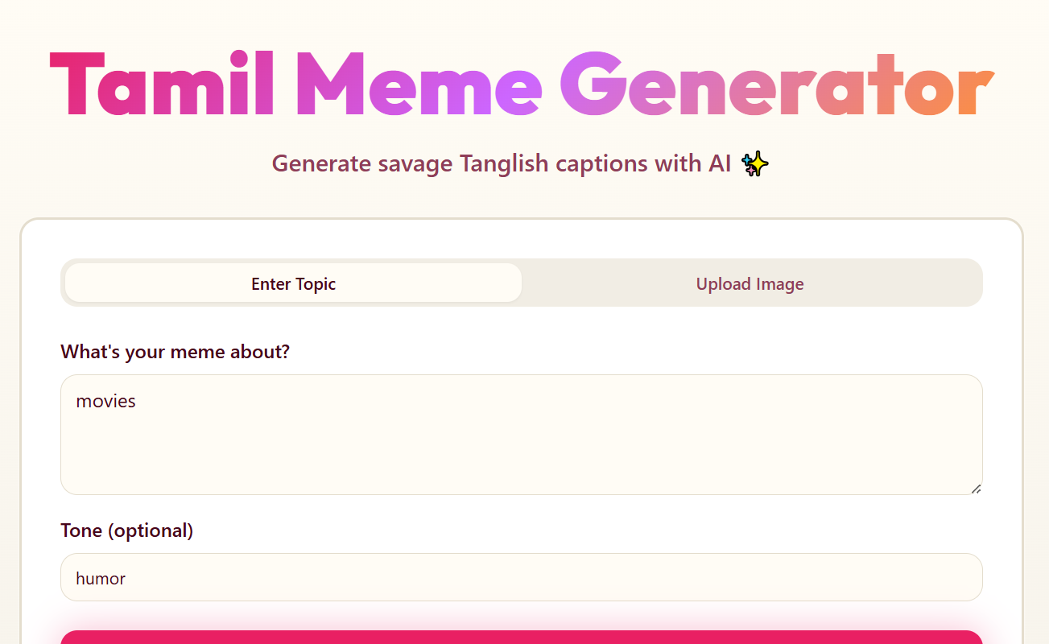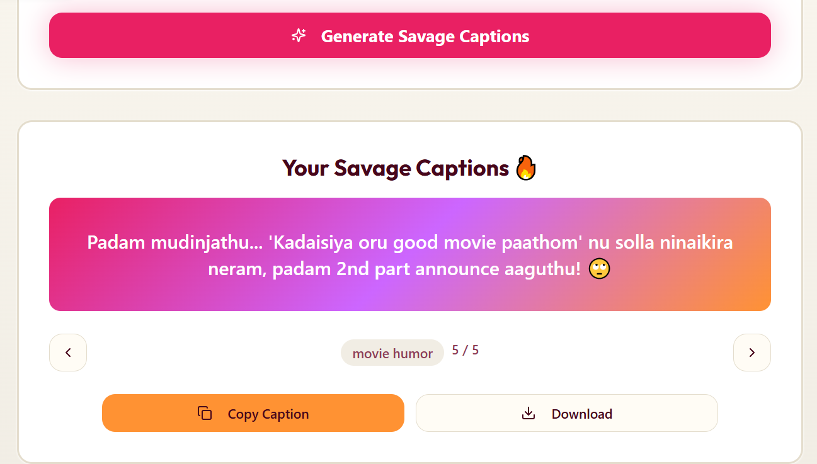
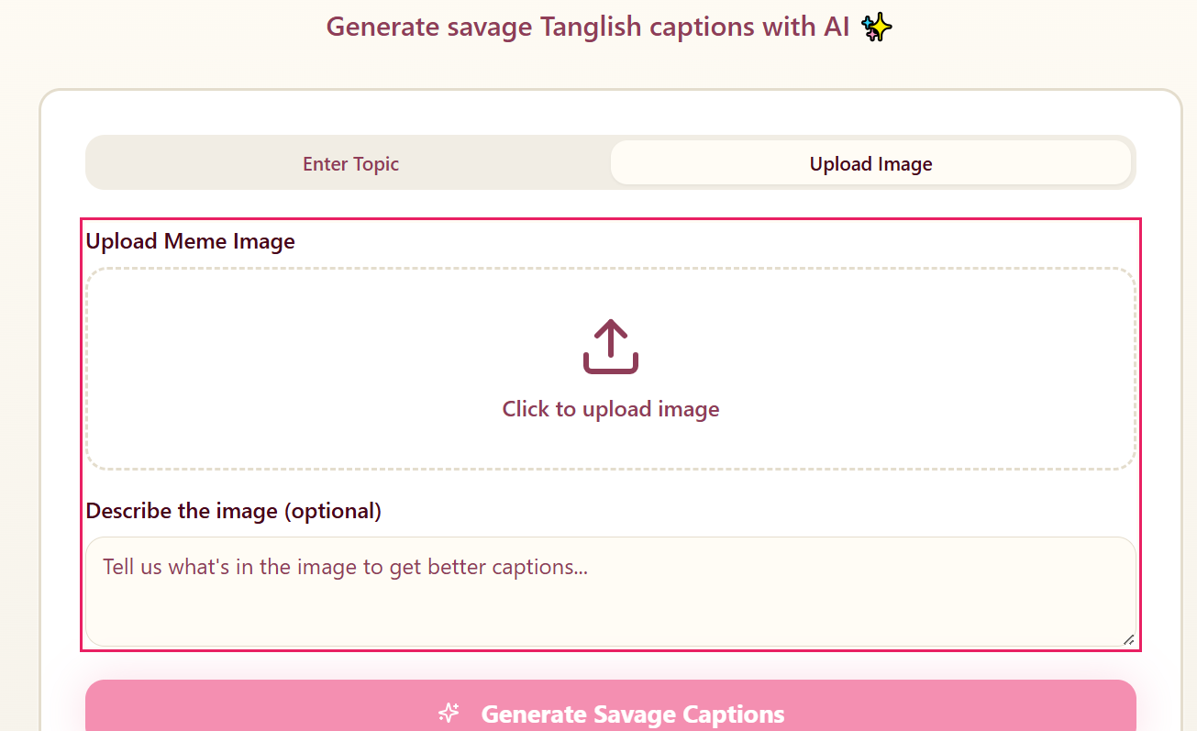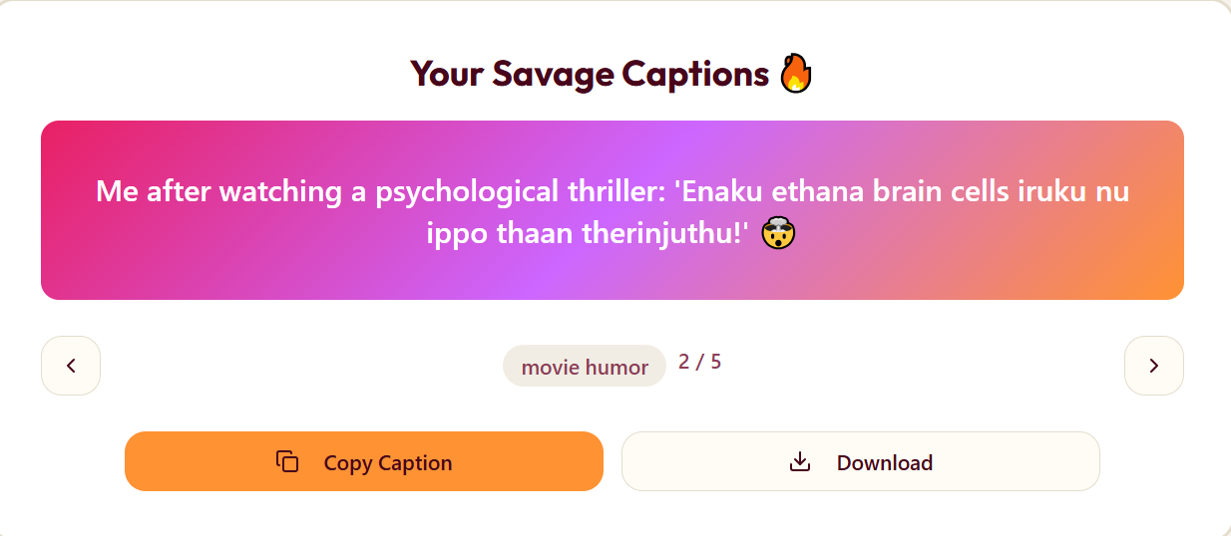

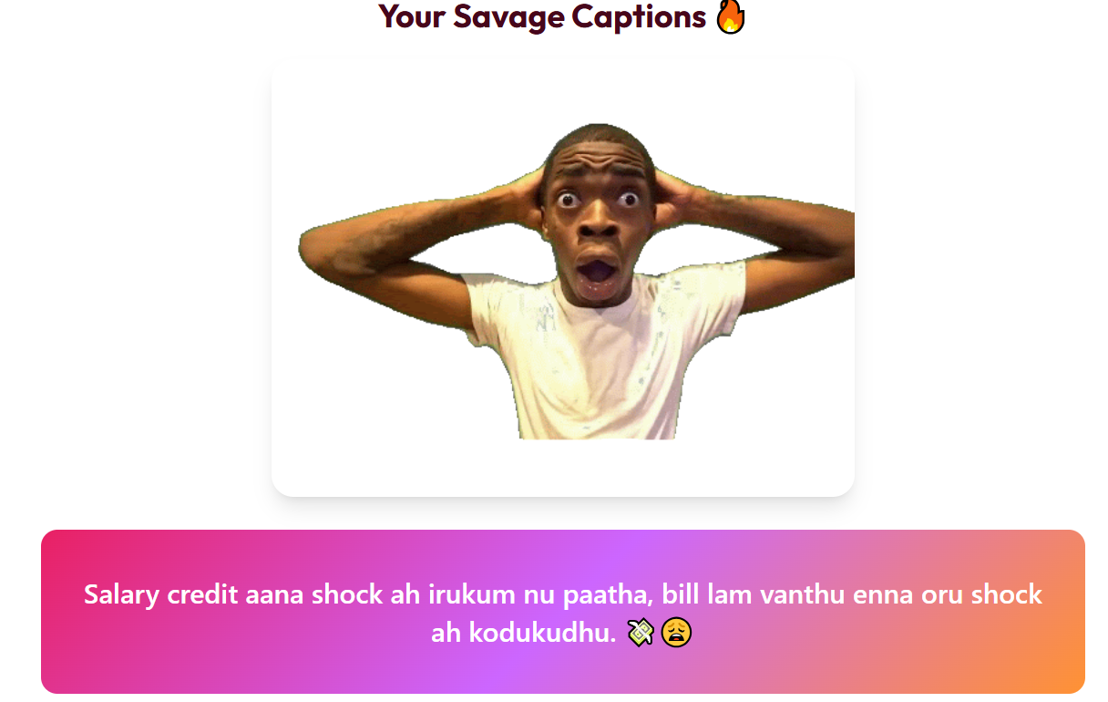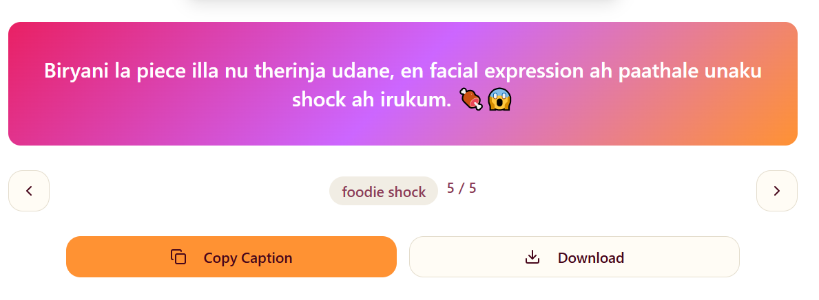

Generated 5 solution mockups using Canva AI + Lovable AI previews.
Friends voted #1 & #4 most practical. Mentors suggested starting simple (captions only).
Day 3: Prototype & Test

Step 6: Prototype
The solution is a clean, user-friendly web app where users input a topic or upload an image, and the AI instantly generates 3–5 savage, funny Tanglish/Tamil meme captions. The interface includes easy copy and share buttons for social media use. The design prioritizes mobile responsiveness and quick results to fit student lifestyles.

AI Tools Selected
- ✅ Lovable AI: No-code web app builder enabling rapid development without server hassles.
- ✅ ChatGPT: Powers the culturally relevant, humor-rich meme caption generation.
- ✅ Canva AI: Used for creating demo screenshots and marketing materials.

Step 7: Test – Getting Feedback
Feedback from classmates and friends was overwhelmingly positive:
- 👍 Fast caption generation with spot-on Tanglish tone and Indian student humor.
- 👍 Loved captions for themes like "exam tomorrow" and "coding bugs."
- 🔧 Requests to improve include adding image upload functionality and expanding the variety of humor tones (festival, savage, motivational).
Testing helped refine prompt quality and validated the value of the meme captions for social sharing, especially within college social groups. This prototype proves the concept is solid and relevant. Next steps would focus on expanding features and polishing the UI.
This approach balances cutting-edge AI with practical user needs, enhancing meme creation speed and cultural relevance for Tamil-speaking youth.

Day 4: Showcase

Step 8: Presenting My Innovation
Final Project Title: Tamil Meme Generator
Problem:
Today’s students love memes, but almost no AI tool understands the unique flavor of Tamil/Tanglish humor. Whether it’s college struggles, exam tension, hostel life, or coding stress, existing generators fail to capture our sarcasm, slang, and cultural references. This leaves students spending too much time creating memes manually.
Innovation:
To solve this, I built a lovable, easy-to-use AI web app integrated with ChatGPT. With just one input—like a situation, mood, or keyword—the app instantly creates 3–5 original Tamil or Tanglish meme captions.
It understands tone (funny, savage, sarcastic, emotional), blends pop culture references, and delivers captions that feel authentically “namma Tamil.”
Demo Example:
Input: "Coding bug"
Output: "Code run aagala, coffee run aachu da 😭☕"
The app generates lines that feel natural, relatable, and ready for Facebook, Instagram, or college WhatsApp groups.
Impact:
This project helps thousands of Indian students save time while creating content that connects with their friends and followers. It boosts social-media engagement, supports student clubs/content creators, and encourages more students to use AI for creativity.

Step 9: Reflections
What I enjoyed most:
I absolutely loved watching AI understand Tamil humor so well—especially when it produced lines that sounded like they came straight from our everyday conversations. Seeing the model capture local slang, inside jokes, and the perfect “saadhu or savage” tone was the most exciting part.
Biggest challenge:
Fine-tuning the prompts to get that exact Tamil meme punch was the toughest part. Making sure the tone stayed consistently funny, sarcastic, or chaotic required lots of testing, experimenting, and refining. But every improvement made the results feel more authentic.

Links
GITHUB: https://github.com/Dharunya16012006/Tamil_Meme_Generator.git
PROJECT: https://tamizh-meme-magic.lovable.app

